Open Boundary
# Source: AI Source: Provided by: [Data Path: Persons Table -> ID Column: 1, Name_En Column: Motasem Essam] -> From: [ChatGPT] on [7/25/2026]
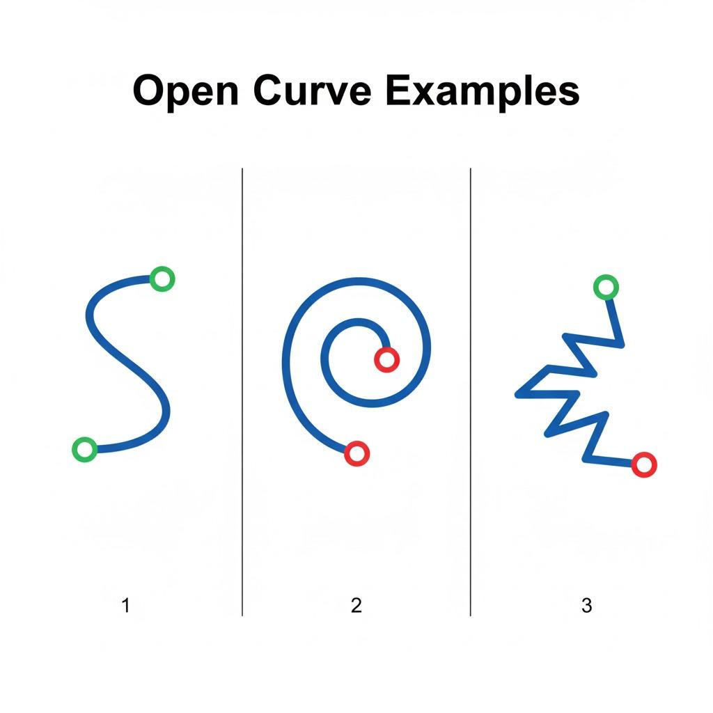
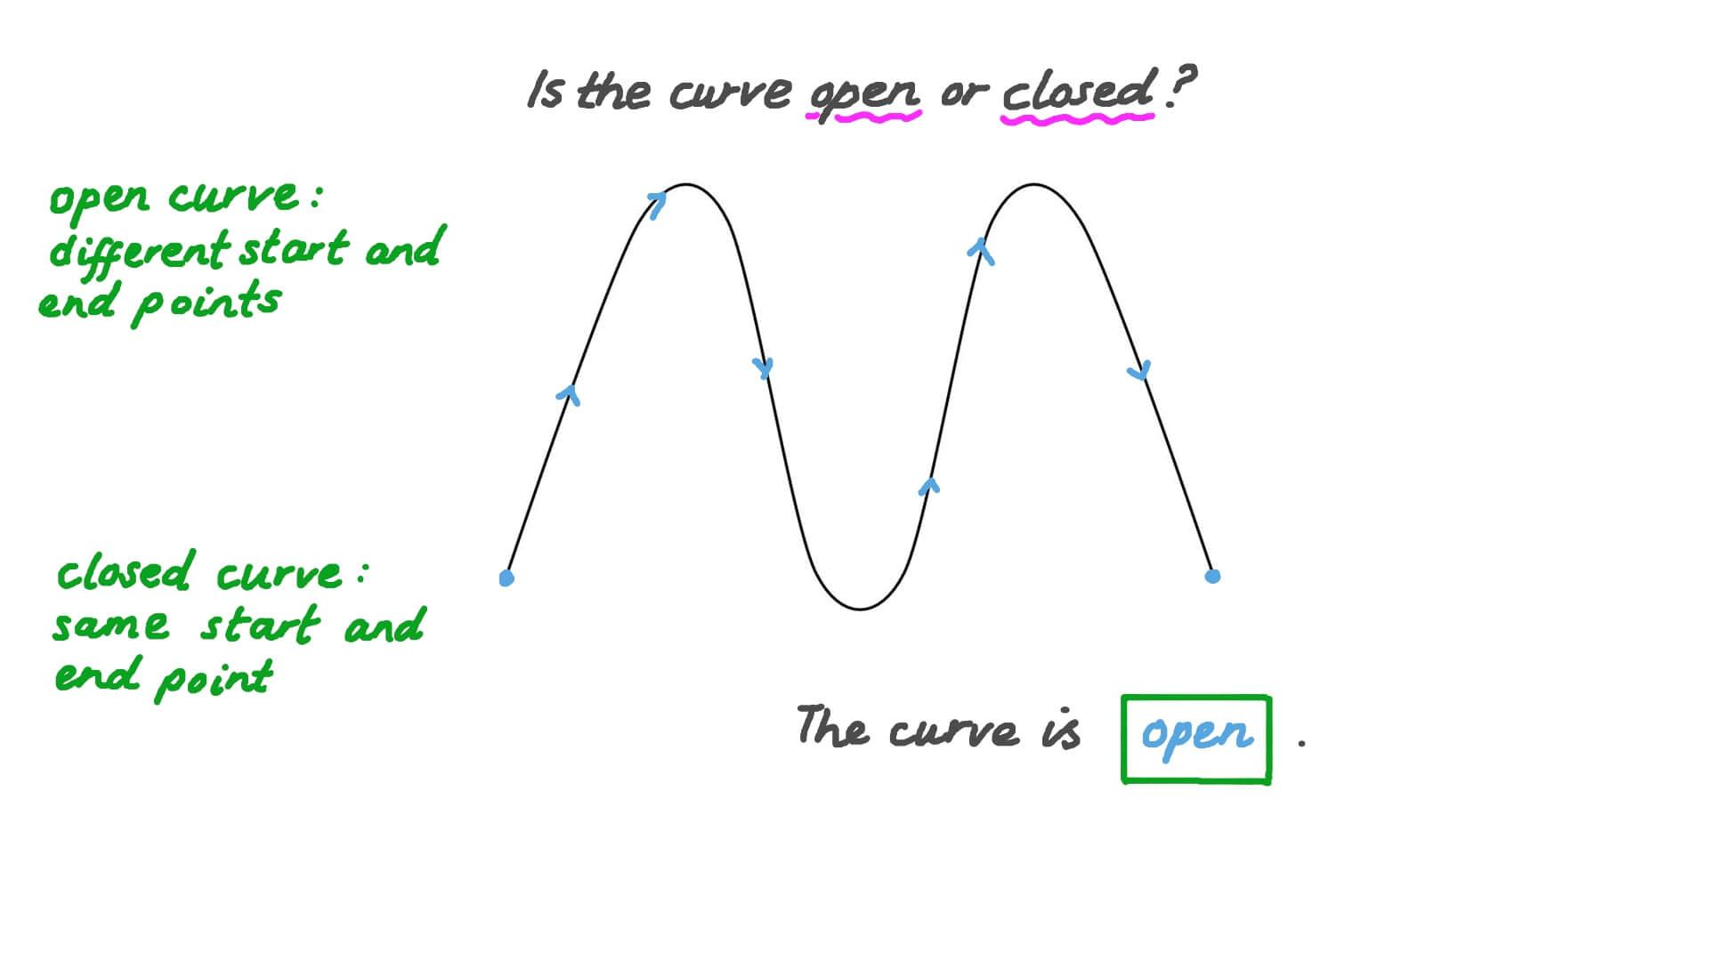
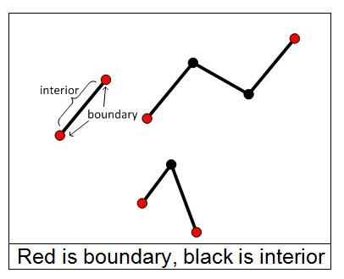

Definition
# Source: AI Source: Provided by: [Data Path: Persons Table -> ID Column: 1, Name_En Column: Motasem Essam] -> From: [ChatGPT] on [7/25/2026]
An Open Boundary is a boundary that does not form a complete closed loop. It has one or more open ends, so it does not completely enclose a region.
Unlike a closed boundary, an open boundary cannot separate the plane into a distinct interior and exterior because there is no fully enclosed area.

Characteristics
# Source: AI Source: Provided by: [Data Path: Persons Table -> ID Column: 1, Name_En Column: Motasem Essam] -> From: [ChatGPT] on [7/25/2026]
An open boundary:
- Has one or more open endpoints.
- Does not form a complete enclosure.
- Does not create a bounded region by itself.
- May consist of straight lines, curves, or a combination of both.
- Has length but no enclosed area.
- Contains infinitely many points if it extends indefinitely (such as a line or ray), or finitely many points if it is finite (such as a line segment).

Illustration

Open Line Segment
# Source: AI Source: Provided by: [Data Path: Persons Table -> ID Column: 1, Name_En Column: Motasem Essam] -> From: [ChatGPT] on [7/25/2026]
A────────────B
The line segment has two endpoints and does not enclose any region.

Open Curve
# Source: AI Source: Provided by: [Data Path: Persons Table -> ID Column: 1, Name_En Column: Motasem Essam] -> From: [ChatGPT] on [7/25/2026]
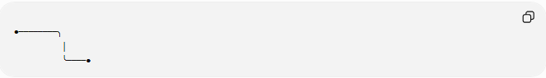
●────────╮
│
╰────●
The curve begins and ends at different points, leaving the boundary open.

Mathematical Representation
# Source: AI Source: Provided by: [Data Path: Persons Table -> ID Column: 1, Name_En Column: Motasem Essam] -> From: [ChatGPT] on [7/25/2026]
An open boundary may be represented by:
- A line segment:
$$\overline{AB}$$
- A ray:
$$\overset{→}{AB}$$
- An open curve:
$$C\left(t\right)$$
where the starting point and ending point are different.

Examples
# Source: AI Source: Provided by: [Data Path: Persons Table -> ID Column: 1, Name_En Column: Motasem Essam] -> From: [ChatGPT] on [7/25/2026]
Example 1 – Line Segment
A single line segment:
A────────B
is an open boundary because it does not enclose a region.

Example 2 – Ray
A──────────────→
A ray extends infinitely in one direction and is an open boundary.

Example 3 – Arc
A circular arc alone is an open boundary because it does not complete the circle.

Example 4 – Polyline
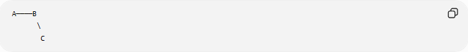
A────B
\
C
The connected segments still do not form a closed figure.

Properties
# Source: AI Source: Provided by: [Data Path: Persons Table -> ID Column: 1, Name_En Column: Motasem Essam] -> From: [ChatGPT] on [7/25/2026]
1. No Enclosed Region
An open boundary alone cannot define an interior region.

2. Endpoints Exist
Most open boundaries have distinct starting and ending points (except infinite lines, which extend endlessly).

3. Finite or Infinite
An open boundary may be:
- Finite (line segment, arc).
- Infinite (line, ray).

4. No Interior–Exterior Separation
Since it does not close, it cannot separate the plane into inside and outside regions.

Real-World Examples
# Source: AI Source: Provided by: [Data Path: Persons Table -> ID Column: 1, Name_En Column: Motasem Essam] -> From: [ChatGPT] on [7/25/2026]
Open boundaries include:
- A road centerline.
- A river path on a map.
- An unfinished fence.
- A measuring tape laid flat.
- A railway track.
- An electrical wire.
- A drawn arc.
- A hiking trail.

Applications
# Source: AI Source: Provided by: [Data Path: Persons Table -> ID Column: 1, Name_En Column: Motasem Essam] -> From: [ChatGPT] on [7/25/2026]
Open boundaries are used in:
- Plane Geometry
- Coordinate Geometry
- Analytic Geometry
- Topology
- Computer Graphics
- CAD (Computer-Aided Design)
- GIS (Geographic Information Systems)
- Engineering
- Surveying
- Robotics

Advantages
# Source: AI Source: Provided by: [Data Path: Persons Table -> ID Column: 1, Name_En Column: Motasem Essam] -> From: [ChatGPT] on [7/25/2026]
Studying open boundaries helps to:
- Model paths and trajectories.
- Represent incomplete or non-enclosing shapes.
- Analyze curves and line segments.
- Describe movement and direction.
- Build more complex geometric figures.

Limitations
# Source: AI Source: Provided by: [Data Path: Persons Table -> ID Column: 1, Name_En Column: Motasem Essam] -> From: [ChatGPT] on [7/25/2026]
An open boundary:
- Does not enclose an area by itself.
- Cannot define an interior region alone.
- Does not separate interior from exterior.

Comparison with Other Boundary Types
# Source: AI Source: Provided by: [Data Path: Persons Table -> ID Column: 1, Name_En Column: Motasem Essam] -> From: [ChatGPT] on [7/25/2026]
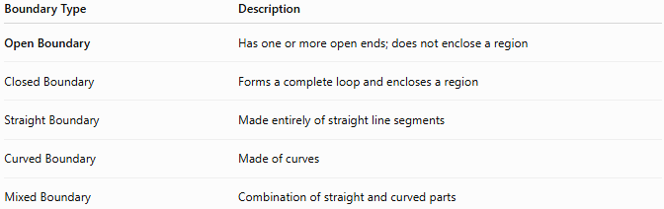
Boundary Type | Description
Open Boundary | Has one or more open ends; does not enclose a region
Closed Boundary | Forms a complete loop and encloses a region
Straight Boundary | Made entirely of straight line segments
Curved Boundary | Made of curves
Mixed Boundary | Combination of straight and curved parts

Key Points
# Source: AI Source: Provided by: [Data Path: Persons Table -> ID Column: 1, Name_En Column: Motasem Essam] -> From: [ChatGPT] on [7/25/2026]
- An Open Boundary does not form a complete loop.
- It cannot enclose a region by itself.
- It may consist of:
  - Line segments.
  - Rays.
  - Lines.
  - Curves.
  - Arcs.
- Open boundaries are commonly used to represent paths, edges, and trajectories.

Conclusion
# Source: AI Source: Provided by: [Data Path: Persons Table -> ID Column: 1, Name_En Column: Motasem Essam] -> From: [ChatGPT] on [7/25/2026]
An Open Boundary is a boundary with one or more open ends that does not completely enclose a region. Because it does not form a closed loop, it cannot define a distinct interior and exterior by itself. Open boundaries are fundamental in plane geometry, coordinate geometry, analytic geometry, topology, engineering, surveying, GIS, CAD, robotics, and computer graphics, where they are used to model paths, curves, edges, and other geometric features that do not form enclosed shapes.

